Activity 1

SimpleWeb folder created in C:\Users\002NVU744\Docker

package.json

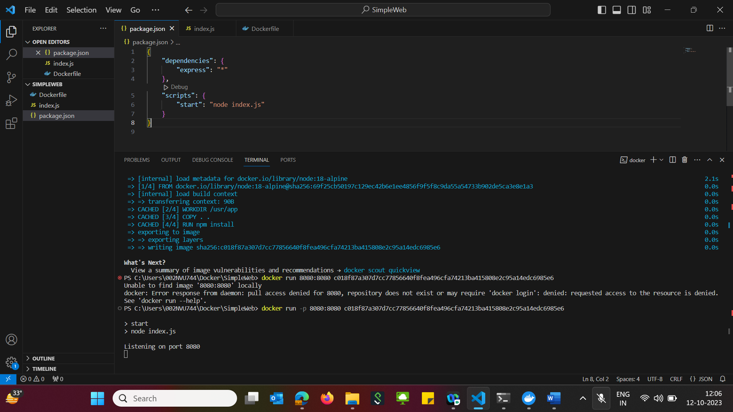

index.js

Dockerfile

Open Terminal

To get Image Id, give command- docker build .

Copy the image id highlighted below

Now run the docker with the image id got from above->

docker run -p 8080:8080 018f87a307d7cc77856640f8fea496cfa74213ba415808e2c95a14edc6985e6

Open localhost:8080 in browser

